A Comparative Study of Nested Fisheye, Nested Dropdown, and Accordion Menus in Goal-Oriented Web Navigation Tasks

**CS449/Human Computer Interaction**



**Serkan Kütük (serkankutuk@sabanciuniv.edu) -27054**

**Arda Poyraz (ardapoyraz@sabanciuniv.edu) - 27819**

**Umut Sarp Günüç (gunuc@sabanciuniv.edu) - 26539**

**Berdan Şen (berdansen@sabanciuniv.edu) - 22472**

**Abstract**

This study evaluates the usability and user experience of three different menu types (Nested Dropdown, Nested Fisheye, and Accordion) in goal-oriented web navigation tasks. The aim of the research is to determine which menu type provides the most efficient, satisfying, fast and easy-to-learn navigation experience for users in goal-oriented tasks. 24 participants from different age groups and professions, with varying levels of technological diversity, were included in the study. Participants were asked to complete specific objectives using all three menu types, and the time they took to complete the tasks was recorded. In addition, feedback from the participants was collected with questions prepared based on the Likert scale. The results of the study show that the nested dropdown menu type is the most accurate of the three menu types for goal-oriented tasks. While the Accordion menu showed a moderate performance, it was determined that the nested fisheye menu was not efficient enough in goal-oriented tasks.

* **Background of the Study**

Different menu types and designs are of great importance in interface design in terms of optimizing the experience of users and ensuring that they access the information they are looking for easily and efficiently. The purpose of the current study is to compare nested fisheye, nested drowdown, and accordion menu types in terms of analysing their usability, efficiency, and speed in sidebars. Based on the context of the current study, various studies, that investigate the effect of different menu types on user performance and satisfaction, has been compiled in a way that can contribute to the current study.

Bederson is a researcher who has studied ways to enhance user performance when navigating long menus. In his study, Bederson (2003) worked with ten participants, who tested four different types of menus—arrowBar, scrollbar, hierarchical, and fisheye—and then evaluated these menus based on seven specific features such as usability and learnability using a Likert scale system. Findings from feedback given by ten users show that the arrowbar menu is considered the worst in terms of performance. Generally, users found scrollbar menus reasonable for both goal-directed and browsing tasks, while hierarchical menus were the most accepted for goal-oriented tasks. Fisheye menus, which highlight the area around the mouse cursor for quick browsing in long menus, became the most preferred for browsing tasks by all users. Additionally, the results showed that fisheye menus were easy to learn for technically proficient users, however, difficult for inexperienced users who are less familiar with technology.

In a study conducted by Tucker, Summers, McGowan, and Klimas (2018), the researchers examined individuals with low literacy levels, specifically those reading at an 8th-grade level or below in the United States. The study focused on assessing how well these individuals could navigate and comprehend user interfaces designed in an accordion style. Additionally, the research analyzed the impact of accordion-style text compared to plain-text interfaces on the continuity of information processing and the frequency of errors in form filling. The goal was to determine whether the accordion-style design improved usability and reduced errors for users with low literacy. The findings of the study show that although interfaces designed in accordion format do not provide a significant advantage in tasks such as filling out forms over users with low literacy levels, they offer users a better experience in reducing form filling time and increasing data entry accuracy.

Another study by Dix, Finlay, Abowd, and Beale (2003) highlights the importance of human factors in human-computer interaction. It focuses on human cognitive psychology, information processing abilities, and the limitations of sensory channels. The aim is to improve user interfaces by examining how humans process information and solve problems. This study reviews existing literature on human psychology and its impact on HCI, analyzes various theories and models, and explores the structure of the human brain. Research shows that people can hold only 7±2 pieces of information in their short-term memory (Dix, Finlay, Abowd, & Beale, 2003). Therefore, user interface design should minimize cognitive load. The study also emphasizes considering individual differences to enhance usability during the design process of interfaces.

* Purpose of the Study

The current study was conducted to evaluate the usability and user experience of three different menu types: Nested Fisheye, Nested Dropdown, and Accordion. The main purpose of the study was to determine which menu type among these three provides the most efficient, satisfying, fast, and easy-to-learn navigation experience for users in a goal-oriented task. Speaking of the goal-oriented task, users are expected to reach the target menu element by following specific steps rather than browsing through a long list such as a library list. By ensuring that these 3 menu types are tested with variations on 3 different tasks, it was aimed to prevent short-time memory bias and to test each type fairly. Data was collected by recording the time it took the participants to complete the task given in each menu type, receiving their feedback after each menu test, and measuring their general satisfaction about each them by benefiting from Likert scale questions. It was intended to contribute to the design processes of web-development interfaces, especially for goal-oriented tasks, and shed light on ensuring user satisfaction by the current study.

* Significance of The Study

The pilot test by Bederson provides important findings specific to fisheye menus, which are relevant to the current study. In the current research, users chose from nested/accordion menus in 3 stages: 20 elements in the first, 17 in the second, and 10 in the third, totaling 47 elements. Although it seems like a browsing-oriented experience is expected, the goal is for users to click on the skirt at the last stage. After trying the first menu type, users might navigate the remaining menus faster due to short-term memory, which could disadvantage the nested fisheye menus. Additionally, since the participants' technological knowledge in the current study can be considered to be above the average, this might improve their speed and satisfaction with the nested fisheye menus. Bederson's work is important as it highlights the potential of fisheye menus to improve user performance in browsing tasks, which is directly related to the current study's focus on different menu types (Bederson & Shneiderman , 2003). Understanding the strengths and weaknesses of fisheye menus, particularly ease of learning for tech-savvy users and challenges for those less familiar with technology, informs the design and evaluation of nested fisheye menus in this study.

The study - conducted by Tucker, Summers, McGowan, and Klimas (2018) - and its results are important because they provide essential insights into how accordion web elements impact user engagement, reading persistence, and form completion accuracy, especially for low-literacy populations. These findings are directly relevant to the current ressearch comparing nested-fisheye, nested-dropdown, and accordion menus in sidebars, as they highlight the usability benefits and potential challenges of accordion interfaces. Understanding that accordion elements can reduce information overload while also posing interaction costs (Tucker, Summers, McGowan, & Klimas, 2018) helps inform the design choices for the current study. This knowledge allows the study to assess how different menu types can enhance accessibility and usability for diverse user groups, ultimately aiming to identify the most effective sidebar menu design that improves user experience and task completion rates.

The current study focuses on the interactions of people with different backgrounds with 3 different menu types (nested fisheye, nested dropdown, accordion). The study conducted by Dix et al. states that the presence of people with different backgrounds should be taken into consideration in the design process (Dix, Finlay, Abowd, & Beale, 2003). The current study focuses on their interactions with different individuals rather than the design process of different menu types. For this reason, differences such as familiarity with technology should also be taken into account in the analysis and results sections of the current study when determining the relationship between users and menu types. In addition, since users will try 3 different menu types consecutively, some precautions should be taken in the design process of the menu types that will be presented to the participants in order to create randomness among them and eliminate the effect of short-time memory. These precautions may include differences in the tasks given to participants and changing the order of menus during tests.

* **Methodology**
* Research Questions

The purpose of the study is to discover which menu type - Nested Fisheye, Nested Dropdown, or Accordion - provides the fastest, most efficient, satisfying, and user-friendly navigation experience in goal-oriented tasks. In addition, the effect of the parameters expressing the participants' age and predisposition to technology on the user experience was also taken into account. For this purpose, answers to the following questions were sought during the conduct of the study:

1. Among these 3 menu types, Nested Fisheye, Nested Dropdown, and Accordion, which menu type allows users to complete tasks in the shortest amount of time?
2. In terms of overall experience, which menu type give users a more satisfying experience?
3. Which menu type did users find the easiest and the most challenging to use, and how do these preferences correlate with their and level of technological proficiency?
4. Which menu type did users find most challenging to learn, and how is this difficulty related to their technological proficiency?
5. Are there significant differences in user preferences and performance between the three menu types based on their task completion times and feedback?

* Personas

24 volunteers participated in this study, and the participants were selected from different age groups and different occupational groups such as students, teachers, and office workers. The participants were randomly selected from among the acquaintances of the study organizers, taking into account their different technology aptitude levels and ages. The demographic information of the participants was balanced by considering various characteristics such as age, gender, profession, and frequency of technology use in order to increase the generalizability of the results of the study. In addition, users were asked to indicate how technologically competent they are out of 10, which will be taken into account when evaluating the research results. Detailed information about the participants is given below:



**Name:** Hakkı Zambak

**Age:** 23

**Gender:** Male

**Education Level:** Senior Student in Computer Science at Sabancı University

**Background Information:**Hakkı is a senior student at Sabancı University in the Computer Science and Engineering department. Because of his department, he is good with technology. However, he is trying to reduce the time he spends on technology.

**Technological Capabilities:** 4 out of 5



**Name:** Meltem Oras

**Age:** 23

**Gender:** Female

**Education Level:** Senior Student in Industrial Engineering at Sabancı University

**Background Information:**Meltem is a senior Industrial Engineering student at Sabancı University. Her ability with technology is average; She can use various technological tools, but she does not consider herself too technology savvy

**Technological Capabilities:** 3 out of 5



**Name:** Selin Özkan

**Age:** 22

**Gender:** Female

**Education Level:** Senior Student in Economy at Sabancı University

**Background Information:** Selin  is a senior student at Sabancı University in the Economy department. Because of her passion of online shopping she is good with technology.

**Technological Capabilities:** 3 out of 5



**Name:** Ege Altınsoy

**Age:** 23

**Gender:** Male

**Education Level:** Senior Student in Computer Science  at Sabancı University

**Background Information:** Ege is a senior student at Sabancı University in the Computer Science and Engineering department. Because of his department, he is good with technology.

**Technological Capabilities:** 4 out of 5



**Name:** Serra Bayraktar

**Age:** 22

**Gender:** Female

**Education Level:** Junior Student in Computer Science at Sabancı University

**Background Information:**Serra is a junior student at Sabancı University in the Computer Science and Engineering department. Because of his department, she is good with technology.

**Technological Capabilities:** 4 out of 5



**Name:** Mustafa Güneş

**Age:** 43

**Gender:** Male

**Education Level:** High school graduate

**Background Information:** Mustafa is a hairdresser. He is not very good with technology. The technological product he generally uses is television. He only uses his phone for his social media accounts..

**Technological Capabilities:** 2 out of 5



**Name:** Eren Özçatalbaş

**Age:** 21

**Gender:** Male

**Education Level:** Junior Industrial Engineering Student at Sabancı University

**Background Information:**Eren is a junior industrial engineering student at Sabancı, currently in his third year of education. He has been highly involed in technology since his childhood, that is one of the reasons he was chosen for this assignment.

**Technological Capabilities:** 4 out of 5



**Name:** Burak İnkaya

**Age:** 22

**Gender:** Male

**Education Level:** Senior Computer Science Student at Sabancı University

**Background Information:**Burak is a senior student at Sabancı University in the Computer Science and Engineering department. Because of his department, he is good with technology.

**Technological Capabilities:** 5 out of 5



**Name:** Alanur Bilgili

**Age:** 24

**Gender:** Female

**Education Level:** Graduated from Özyeğin University

**Background Information:**Alanur is a Data Science Engineer in SAP. Because of her job , she is good at use of technology and she has a full confidence in menu adaptations.

**Technological Capabilities:** 5 out of 5



**Name:** Fulya Aras

**Age:** 39

**Gender:** Female

**Education Level:** Graduated from Marmara University

**Background Information:**Fulya is a chemistry teacher and is not bad with technology, but she does not see herself as sufficient. She can sometimes shop from various online platforms and use social media, but other than that, she uses technology very few.

**Technological Capabilities:** 2 out of 5



**Name:** Fatih Mehmet Ak

**Age:** 41

**Gender:** Male

**Education Level:** Graduated from Sakarya University

**Background Information:** Fatih is a Math teacher and is not bad with technology, but he does not see himself as sufficient. He can sometimes shop from various online platforms and use social media, but other than that, she uses technology very few..

**Technological Capabilities:** 3 out of 5



**Name:** Bilginer Sarı

**Age:** 26

**Gender:** Male

**Education Level:** Senior Student in Economy at Sabancı University

**Background Information:**Bilginer is a senior student at Sabancı University in the Economy department. Because of his passion for technological startups, he is good with technology.

**Technological Capabilities:** 4 out of 5



**Name:** Zekeriya Vatan

**Age:** 24

**Gender:** Male

**Education Level:** Graduated from Kocaeli University

**Background Information:**Zekeriya currently works in an auto repair shop in the industry and he is generally not involved with technology other than his social media accounts on his phone.

**Technological Capabilities:** 3 out of 5



**Name:** Kaan Temel

**Age:** 24

**Gender:** Male

**Education Level:** Graduated from Sabancı University

**Background Information:**Kaan is a Data Science Engineer in Arçelik. Because of his job , he is good at use of technology and  he has no doubt with menu adaptation capabilities.

**Technological Capabilities:** 5 out of 5



**Name:** Akay Kanbir

**Age:** 24

**Gender:** Male

**Education Level:** Senior Computer Science Student at Sabancı University

**Background Information:**Akay is a senior student at Sabancı University in the Computer Science and Engineering department. Because of his department, he is good with technology.

**Technological Capabilities:** 4 out of 5



**Name:** Asiye Altun

**Age:** 22

**Gender:** Female

**Education Level:** Sophomore Computer Science Student at Okan University

**Background Information:**Asiye states that technology use is low, except for doing some simple homework, using social media and online shopping, but  her technology usage is better than the general average.

**Technological Capabilities:** 3 out of 5



**Name:** Samet Sandal

**Age:** 25

**Gender:** Male

**Education Level:** High school graduate

**Background Information:** Samet is a carpet seller. He is not very good with technology. The technological product he generally uses is television. He only uses his phone for his social media accounts..

**Technological Capabilities:** 3 out of 5



**Name:** Celal Boyraz

**Age:** 41

**Gender:** Male

**Education Level:** High school graduate

**Background Information:** Celal is a security guard. He is not very good with technology. The technological product he generally uses is television. He only uses his phone for his social media accounts..

**Technological Capabilities:** 2 out of 5



**Name:** Ceren Gizem Arı

**Age:** 25

**Gender:** Female

**Education Level:** Graduated from Dokuz Eylül University

**Background Information:**Ceren is a dentist and she is not bad with technology, but she does not see herself as sufficient. She can sometimes shop from various online platforms and use social media, but other than that, she uses technology very few.

**Technological Capabilities:** 2 out of 5



**Name:** Yağız Cebişli

**Age:** 24

**Gender:** Male

**Education Level:** Graduated from Sabancı University

**Background Information:**Yağız is a Data Science Engineer in Peak Games. Because of his job , He is very good at use of technology and he has a  full confidence in menu adaptations.

**Technological Capabilities:** 5 out of 5



**Name:** Atakan Yılmaz

**Age:** 33

**Gender:** Male

**Education Level:** Graduated from Sabancı University

**Background Information:** Atakan is the owner of a company called Creative Minds and since he is a startup person, he is a very competent person in terms of technology and adaptation.

**Technological Capabilities:** 5 out of 5



**Name:** Erdem Adıgüzel

**Age:** 25

**Gender:** Male

**Education Level:** Graduated from Sabancı University

**Background Information:**Erdem is an industrial engineer in ATV. He is exposed to technology every day due to his job and relies on his technological adaptation.

**Technological Capabilities:** 4 out of 5



**Name:** Ali Dursun

**Age:** 24

**Gender:** Male

**Education Level:** High school graduate

**Background Information:**Atakan is the owner of a company named Ratic Studio and since he is a startuper, he is a very competent person in terms of technology and adaptation.

**Technological Capabilities:** 4 out of 5



**Name:** Samet Vatan

**Age:** 24

**Gender:** Male

**Education Level:** Graduated from Yeditepe University

**Background Information:**Samet is a lawyer and he is generally not involved with technology other than his social media accounts on his phone.

**Technological Capabilities:** 3 out of 5

* What materials were employed (systems, questionnaires - design, validity and reliability)

**-Systems**

In the study, 3 menu types - Nested Dropdown, Nested Fisheye, and Accordion - are constructed benefiting from HTML and CSS.

During the execution of the study, three user interfaces were created using HTML and CSS markup languages. To briefly describe the menu systems created:

1. **Nested Dropdown Menu** is a widely-used menu type that uses traditional drop-down elements where clinking on a parent item reveals a list of child items. It offers a multi-level experience to users. It provides a multi-level structure, making it easy to classify elements within the menu.
2. **Nested Fisheye Menu** type makes it easier to read the text in the menu by enlarging the items that users mark with arrows. In the context of the work, the fisheye menu, which is typically used in browse-oriented tasks, has been made nested by adding a multi-layered structure.
3. **The Accordion Menu** type allows child objects to be displayed when parent elements in the menu are clicked. Instead of opening in a nested format like others, it allows classification between items in a single frame.

In addition to these 3 menu types, the same interface is designed for each menu type is used in order to ensure consistency, and avoid causing any differences in performance and feedback based on different interfaces.

As well as user interfaces, the following Python libraries were used to visualize and analyze the collected data:

* + Pandas
  + Matplotlib
  + Seaborn
  + Scipy
  + Statsmodels

**- Questionnaires**

**Pre-test Questionnaire:** Before starting the test, each participant was given a brief introduction about the test. At this stage, in order to learn more about the participants, they were asked a number of questions to find out their education levels, professions and ages, and they were asked to score their familiarity with technology between 1 and 5. So at this stage, background data was collected about users.

**Post-task Questionnaire:** After completing each task, participants were asked to provide a feedback about the menu they just tested. By collecting answers to open-ended questions for each menu types, qualitative insights were gained for the sake of the study.

**Pro-test Questionnarie:** At the end of the test, participants, who testes all menu types, were asked to score their experiences with the menu types in 3 aspects on the Likert scale system, in order to evaluate each menu type based on the following criteria:

1. The level of frustration or satisfaction experienced (rated from 1 to 5)
2. The ease or difficulty of use (rated from 1 to 5)
3. The ease of difficulty of learning (rated from 1 to 5)

**- Validity and Reliability**

Since participants would be testing each menu type consecutively, three different tasks were designed to prevent intuitive behavior based on short-term memory and to ensure a thorough evaluation of each menu type. To further reduce any potential bias, the order in which the participants encountered the menu types was varied systematically. The following cycle repeated itself in every six participants:

1. Nested Fisheye (Task 1), Nested Dropdown (Task 2), Accordion (Task 3)
2. Nested Fisheye (Task 1), Accordion (Task 2), Nested Dropdown (Task 3)
3. Nested Dropdown (Task 1), Nested Fisheye (Task 2), Accordion (Task 3)
4. Accordion (Task 1), Nested Fisheye (Task 2), Nested Dropdown (Task 3)
5. Nested Dropdown (Task 1), Accordion (Task 2), Nested Fisheye (Task 3)
6. Accordion (Task 1), Nested Dropdown (Task 2), Nested Fisheye (Task 3)

This approach ensured that each menu type was tested in different positions within the task sequence, reducing order effects and allowing for a balanced evaluation of each menu's usability and learnability.

Likert scale questions were asked at the end of the test to the participants who tested all menu types one by one.

In order to minimize the impact of different parameters on the user experience, all interfaces were designed in the same way for each menu type. Identical sidebars and colors were used in all of them. This consistency ensured that any differences in participants' performance were due to the menu types themselves, rather than other interface elements.

In the study conducted by Dix et al. (2003), since it was stated that the human brain keeps 7±2 elements in short-memory, the root menu was designed so that the number of elements and the number of children of each was greater than 9. In addition, in all tasks, they were expected to choose from 20 options for the first step, 17 options for the second step, and 10 options for the third step. In this way, it was aimed to minimize the impact of the number of options that users had to read in different tasks.

* What data was collected (dependent variables i.e. scores, ratings, responses, verbal feedback)

The data collected in the include a range of dependent variables, demographic information, likert scale ratings, and qualitative feedback and responses, given by participants. The specific data collected could be sum up to:

1. **Demographic Information:** Numerical and verbal data, provided by participants, in which each of them scores their age, gender, education level, occupation and familarity with the technology between 1 and 5
2. **Completion Time:** The time, recorded by testers of the study, taken by participants to complete given tasks using 3 different menu types
3. **Likert Scale Ratings:** Provided information for manu type on a Likert scale, evaulating:
   1. Level of frustration or satisfaction (1 to 5)
   2. Ease of use (1 to 5)
   3. Ease of learning (1 to 5)
4. **Responses and verbal feedback:** Feedback on the overall experience, and additional comments, collected for capturing qualitative insights

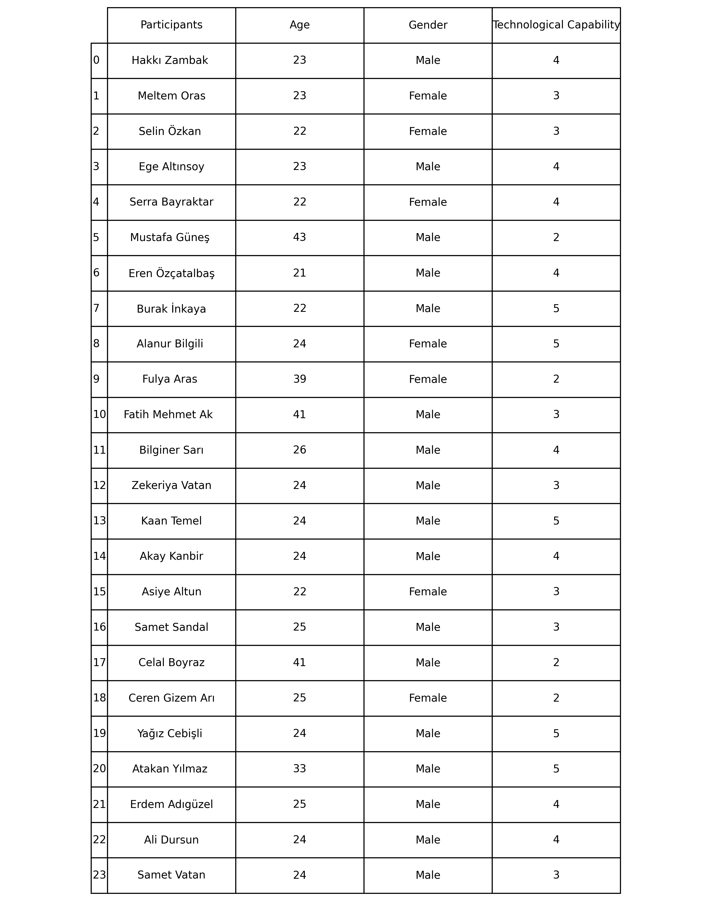

Figure 1

Demographic data collected from participants is clearly visible in Figure 1.

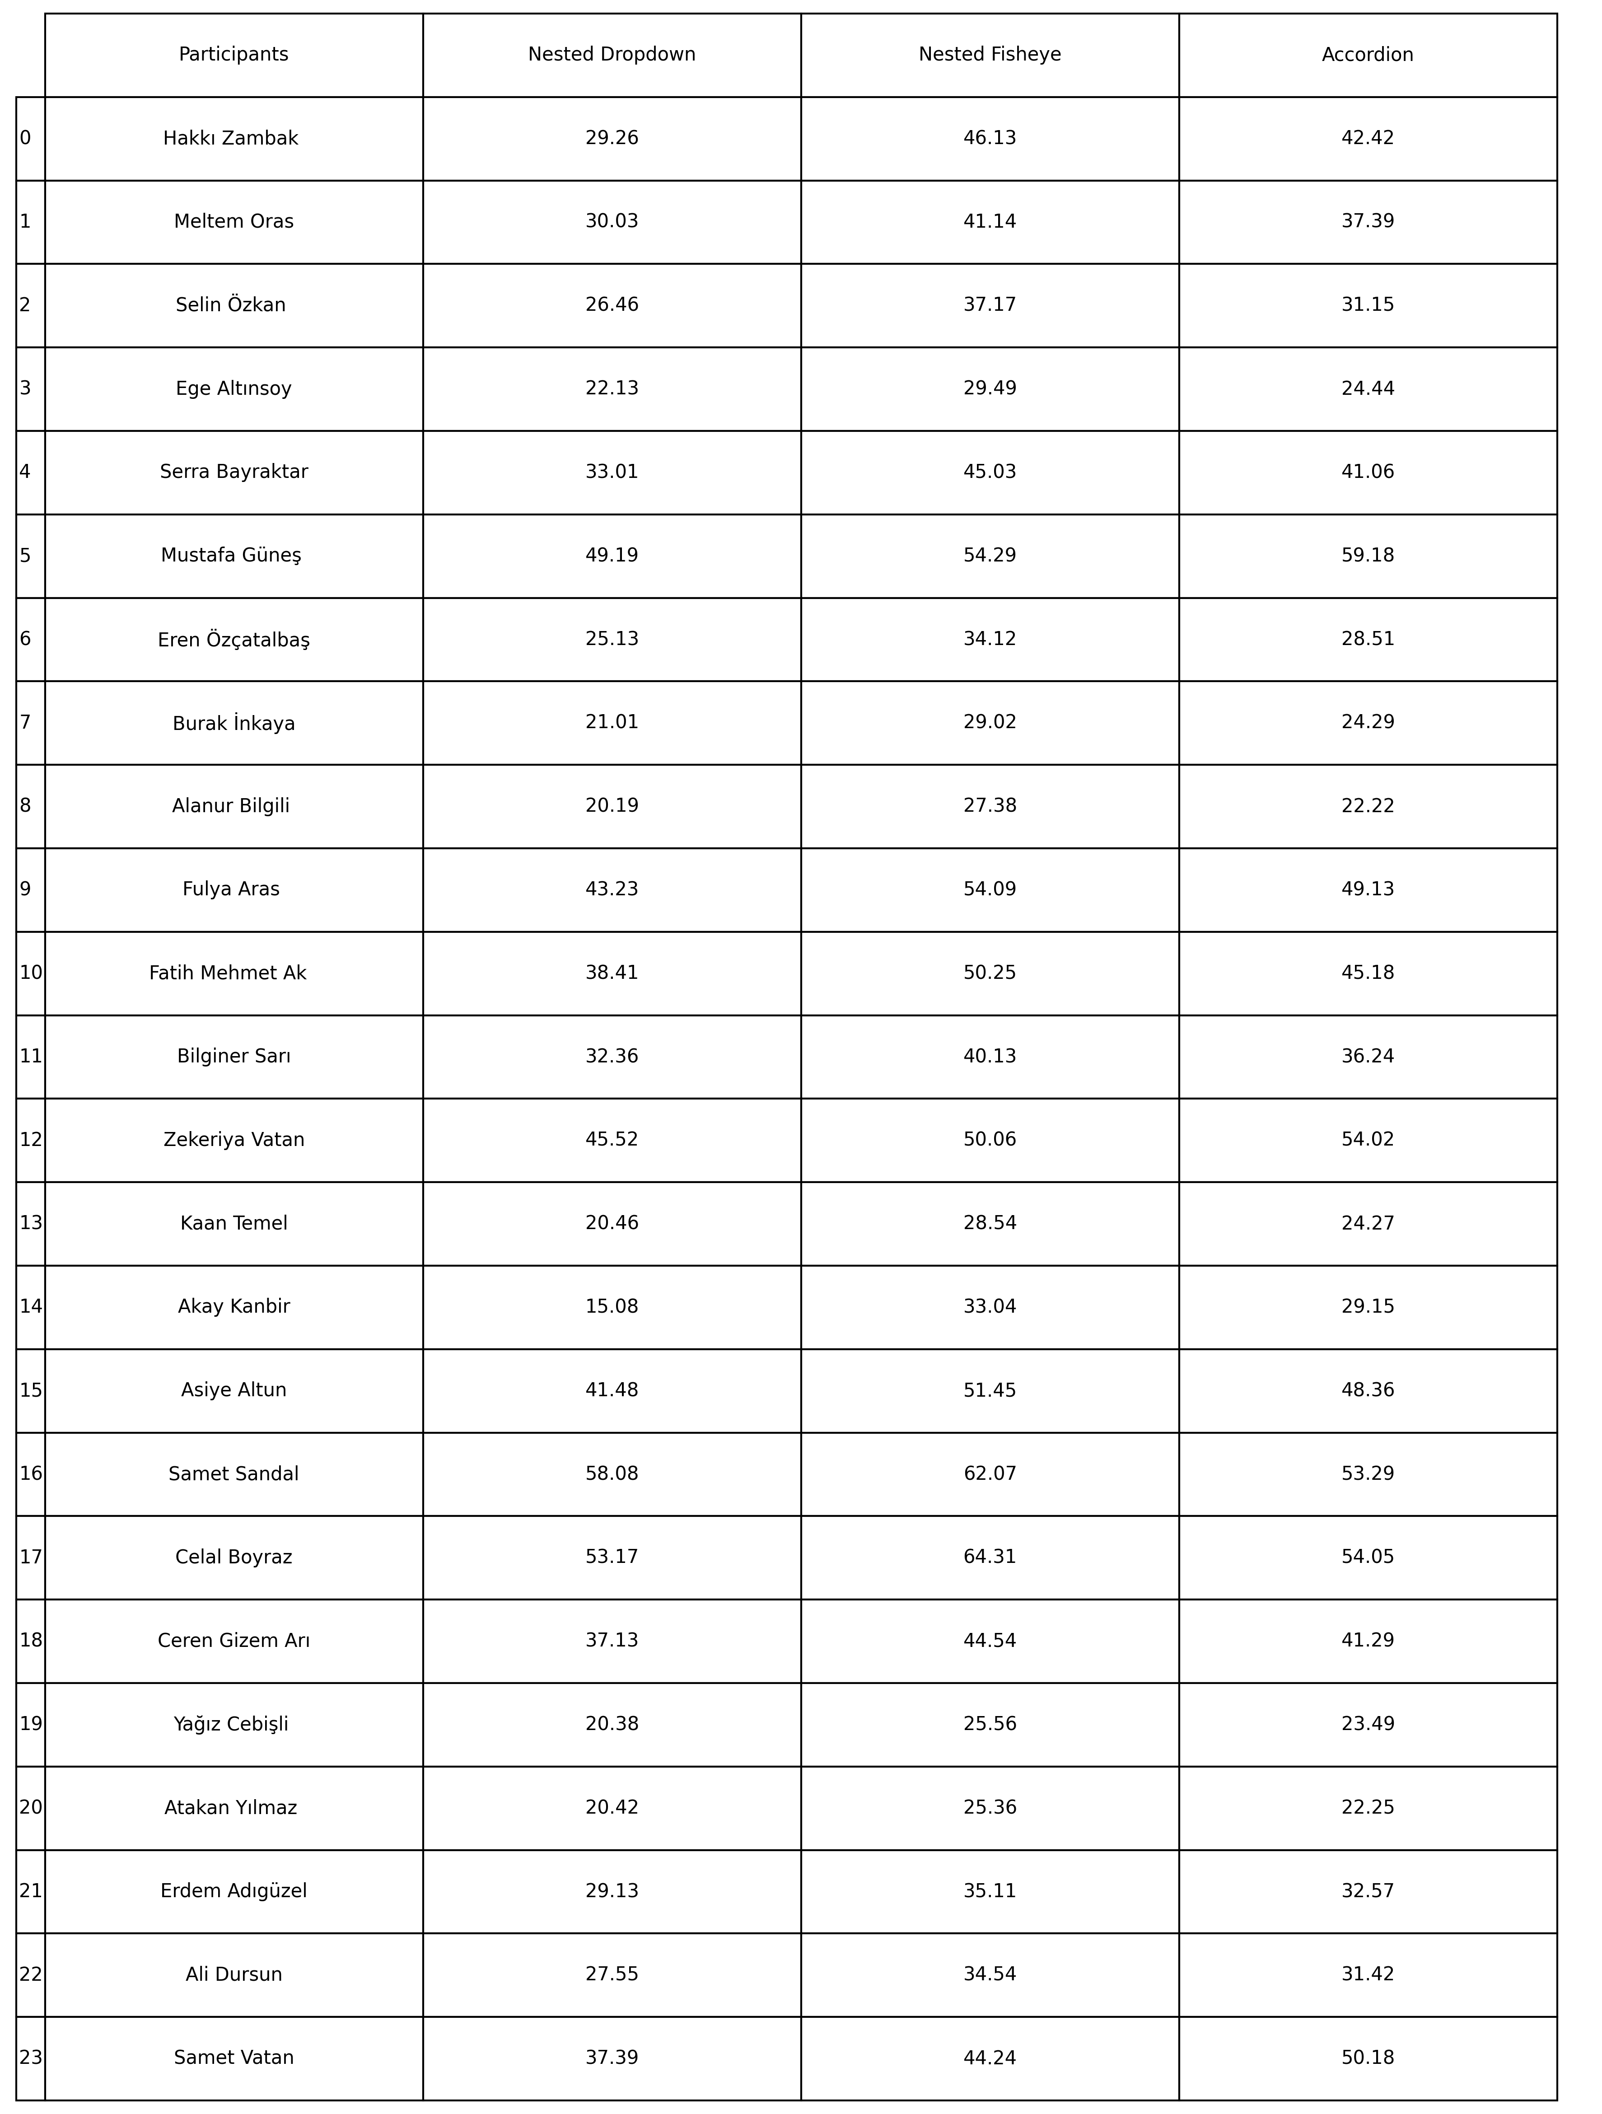

Figure 2

The task completion time of each user for given menu types can clearly be seen in Figure 2.



Figure 3

The scores given by the participants to the Likert Scale questions are shown in Figure 3.

Qualitative data and feedback given by the participants after the completion of each task are shown below:

**Persona 1: Hakkı Zambak**

**Nested Dropdown Menu:**

* **Comment:** "Finding the product was quite easy; dropdown menus really work."

**Nested Fisheye Menu:**

* **Comment:** "Not bad, but not as comfortable as dropdown menus."

**Accordion Menu:**

* **Comment:** "The accordion menu was also quite useful, but it takes some getting used to."

**Persona 2: Meltem Oras**

**Nested Dropdown Menu:**

* **Comment:** "It was easy to use and finding the product was straightforward."

**Nested Fisheye Menu:**

* **Comment:** "Finding some products was a bit challenging, but overall it was comfortable."

**Accordion Menu:**

* **Comment:** "The accordion menu takes some getting used to, but it's not bad."

**Persona 3: Selin Özkan**

**Nested Dropdown Menu:**

* **Comment:** "Dropdown menus are always pretty okay with me , quick and useful."

**Nested Fisheye Menu:**

* **Comment:** "A bit confusing at first, but not hard to learn."

**Accordion Menu:**

* **Comment:** "The accordion menu is also comfortable to use, but could be more intuitive."

**Persona 4: Ege Altınsoy**

**Nested Dropdown Menu:**

* **Comment:** "Dropdown menus are really practical and fast."

**Nested Fisheye Menu:**

* **Comment:** "Using the fisheye menu takes some getting used to, but it's comfortable."

**Accordion Menu:**

* **Comment:** "The accordion menu was quite easy to use, I was satisfied."

**Persona 5: Serra Bayraktar**

**Nested Dropdown Menu:**

* **Comment:** "Dropdown menus are very easy and intuitive to use."

**Nested Fisheye Menu:**

* **Comment:** "It takes a bit of getting used to, but overall it's comfortable."

**Accordion Menu:**

* **Comment:** "The accordion menu was initially challenging but got easier over time."

**Persona 6: Mustafa Güneş**

**Nested Dropdown Menu:**

* **Comment:** "It was a bit difficult to use, but it got better with practice."

**Nested Fisheye Menu:**

* **Comment:** "The fisheye menu was confusing and difficult to use."

**Accordion Menu:**

* **Comment:** "The accordion menu was also a bit confusing, but not too difficult to use."

**Persona 7: Eren Özçatalbaş**

**Nested Dropdown Menu:**

* **Comment:** "Dropdown menus are always easy and comfortable to work with."

**Nested Fisheye Menu:**

* **Comment:** "Initially it was difficult, but once I got used to it, it was comfortable."

**Accordion Menu:**

* **Comment:** "The accordion menu was quite intuitive and easy to use."

**Persona 8: Burak İnkaya**

**Nested Dropdown Menu:**

* **Comment:** "Dropdown menu usage is very fast and practical."

**Nested Fisheye Menu:**

* **Comment:** "Using the fisheye menu takes some getting used to but it was okay."

**Accordion Menu:**

* **Comment:** "The accordion menu is very intuitive and comfortable to use."

**Persona 9: Alanur Bilgili**

**Nested Dropdown Menu:**

* **Comment:** "Dropdown menu usage is very comfortable and intuitive."

**Nested Fisheye Menu:**

* **Comment:** "Using the fisheye menu was also comfortable, but it takes some getting used to."

**Accordion Menu:**

* **Comment:** "The accordion menu is very intuitive and easy to use."

**Persona 10: Fulya Aras**

**Nested Dropdown Menu:**

* **Comment:** "I struggled a bit, but once I learned how to use it, it became easier."

**Nested Fisheye Menu:**

* **Comment:** "It was confusing and hard to use."

**Accordion Menu:**

* **Comment:** "At first it was challenging, but it got easier with practice."

**Persona 11: Fatih Mehmet Ak**

**Nested Dropdown Menu:**

* **Comment:** "It wasn't difficult to use, but could be more practical."

**Nested Fisheye Menu:**

* **Comment:** "I struggled a bit, but overall it wasn't too bad."

**Accordion Menu:**

* **Comment:** "The accordion menu was initially challenging but then I got used to it."

**Persona 12: Bilginer Sarı**

**Nested Dropdown Menu:**

* **Comment:** "Dropdown menus are very practical and easy to use."

**Nested Fisheye Menu:**

* **Comment:** "The fisheye menu was comfortable to use, but takes some getting used to."

**Accordion Menu:**

* **Comment:** "The accordion menu was quite intuitive and comfortable to use."

**Persona 13: Zekeriya Vatan**

**Nested Dropdown Menu:**

* **Comment:** "It wasn't difficult to use, but could be more intuitive."

**Nested Fisheye Menu:**

* **Comment:** "It was a bit confusing and difficult to use."

**Accordion Menu:**

* **Comment:** "It was initially challenging, but got easier over time."

**Persona 14: Kaan Temel**

**Nested Dropdown Menu:**

* **Comment:** "Dropdown menu usage is very intuitive and easy."

**Nested Fisheye Menu:**

* **Comment:** "The fisheye menu was also comfortable to use, but takes some getting used to."

**Accordion Menu:**

* **Comment:** "The accordion menu was very intuitive and comfortable to use."

**Persona 15: Akay Kanbir**

**Nested Dropdown Menu:**

* **Comment:** "Dropdown menus are very practical and easy to use."

**Nested Fisheye Menu:**

* **Comment:** "The fisheye menu was comfortable to use, but takes some getting used to."

**Accordion Menu:**

* **Comment:** "The accordion menu was quite intuitive and comfortable to use."

**Persona 16: Asiye Altun**

**Nested Dropdown Menu:**

* **Comment:** "The dropdown menus were a bit confusing at first, but once I got used to it, it was easy."

**Nested Fisheye Menu:**

* **Comment:** "The fisheye menu was difficult to use and not very intuitive."

**Accordion Menu:**

* **Comment:** "The accordion menu was initially challenging but got easier over time."

**Persona 17: Samet Sandal**

**Nested Dropdown Menu:**

* Comment: "The dropdown menu was a bit confusing, but I managed to use it after a while."

**Nested Fisheye Menu:**

* Comment: "The fisheye menu was difficult to navigate and not very intuitive for me."

**Accordion Menu:**

* Comment: "The accordion menu was more straightforward, but still a bit challenging."

**Persona 18: Celal Boyraz**

**Nested Dropdown Menu:**

* Comment: "I found the dropdown menus a bit overwhelming and hard to use."

**Nested Fisheye Menu:**

* Comment: "The fisheye menu was very confusing and hard to understand."

**Accordion Menu:**

* Comment: "The accordion menu was slightly better, but still not very user-friendly."

**Persona 19: Ceren Gizem Arı**

**Nested Dropdown Menu:**

* Comment: "The dropdown menus were a bit tricky at first, but I got the hang of it."

**Nested Fisheye Menu:**

* Comment: "The fisheye menu was somewhat confusing and took a while to get used to."

**Accordion Menu:**

* Comment: "The accordion menu was easier to understand and use."

**Persona 20: Yağız Cebişli**

**Nested Dropdown Menu:**

* Comment: "The dropdown menus were very intuitive and easy to use."

**Nested Fisheye Menu:**

* Comment: "The fisheye menu was interesting and comfortable to navigate."

**Accordion Menu:**

* Comment: "The accordion menu was very user-friendly and efficient."

**Persona 21: Atakan Yılmaz**

**Nested Dropdown Menu:**

* Comment: "The dropdown menu was very practical and easy to use."

**Nested Fisheye Menu:**

* Comment: "The fisheye menu was interesting and very intuitive."

**Accordion Menu:**

* Comment: "The accordion menu was straightforward and efficient."

**Persona 22: Erdem Adıgüzel**

**Nested Dropdown Menu:**

* Comment: "The dropdown menu was quite easy to use and practical."

**Nested Fisheye Menu:**

* Comment: "The fisheye menu was comfortable but took a bit of time to get used to."

**Accordion Menu:**

* Comment: "The accordion menu was intuitive and easy to use."

**Persona 23: Ali Dursun**

**Nested Dropdown Menu:**

* Comment: "The dropdown menu was practical and easy to navigate."

**Nested Fisheye Menu:**

* Comment: "The fisheye menu was interesting but needed some getting used to."

**Accordion Menu:**

* Comment: "The accordion menu was straightforward and comfortable to use."

**Persona 24: Samet Vatan**

**Nested Dropdown Menu:**

* Comment: "The dropdown menu was a bit confusing at first, but I got the hang of it."

**Nested Fisheye Menu:**

* Comment: "The fisheye menu was quite challenging to navigate."

**Accordion Menu:**

* Comment: "The accordion menu was easier compared to others, but still a bit challenging."
* What were participants required to do (where, who, sequence of events)

Participants in this study were required to interact with three different types of menus (Nested Fisheye, Nested Dropdown, and Accordion) to complete the task, which is given to them. In order to provide reliability, 3 tasks were designed, and these tasks continued in a loop every 6 users. The tasks assigned within this test-design logic are listed below:

1. Task 1 to follow:

🡪 Step 1 - 20 Options: Elektronik, Ev & Mobilya, Süpermarket, Kitap, Müzik Aletleri, Hobi, Ofis ve Kırtasiye, Petshop, Otomotiv, Yapı Market, Bahçe & Outdoor, Seyehat, Oyun & Konsol, Kadın, Erkek, Film & Dizi, Çiçek, Gözlük, Saat, Takı (participant is expected to choose "Kadın")

🡪 Step 2 - 17 Options: Elbise, Tişört, Gömlek, Kot Pantolon, Giyim, Kot Ceket Pantolon, Mont, Bluz, Ceket, Kazak, Büyük Beden, Trençkot, Yağmurluk & Rüzgarlık, Sweatshirt, Kaban, Hırka, Palto (participant is expected to choose "Giyim")

🡪 Step 3 - 10 Options: Abiye Elbise, Günlük Elbise, İç Giyim, Ev Giyim, Spor Giyim, Plaj Giyim, Gece Kıyafeti, Hamile Giyim, İş Giyim, Yoga & Pilates Kıyafetleri (participant is expected to choose "Gece Kıyafeti")

🡪 Task 2 to follow:

🡪 Step 1 - 20 Options: Elektronik, Ev & Mobilya, Süpermarket, Kitap, Müzik Aletleri, Hobi, Ofis ve Kırtasiye, Petshop, Otomotiv, Yapı Market, Bahçe & Outdoor, Seyehat, Oyun & Konsol, Kadın, Erkek, Film & Dizi, Çiçek, Gözlük, Saat, Takı (participant is expected to choose "Ev ve Mobilya")

🡪 Step 2 - 17 Options: Oturma Odası Mobilyaları, Yatak Odası Mobilyaları, Mutfak Mobilyaları, Banyo Mobilyaları, Çocuk Odası Mobilyaları, Ofis Mobilyaları, Bahçe Mobilyaları, Depolama ve Düzenleme Ürünleri, Aydınlatma Perde ve Stor, Halı ve Kilim, Dekoratif Ürünler, Yemek Odası Mobilyaları, Mobilya Aksesuarları, Ev Tekstili, Ayakkabılık ve Portmanto, Mobilya Tamir ve Bakım Ürünleri (participant is expected to choose "Aydınlatma Perde ve Stor")

🡪 Step 3 - 10 Options: Avize, Lambader, Tül Perde, Stor Perde, Abajur, Jaluzi, LED Aydınlatma, Fon Perde, Masa Lambası, Zebra Perde (participant is expected to choose "Tül Perde")

🡪 Task 3 to follow:

🡪 Step 1 - 20 Options: Elektronik, Ev & Mobilya, Süpermarket, Kitap, Müzik Aletleri, Hobi, Ofis ve Kırtasiye, Petshop, Otomotiv, Yapı Market, Bahçe & Outdoor, Seyehat, Oyun & Konsol, Kadın, Erkek, Film & Dizi, Çiçek, Gözlük, Saat, Takı (participant is expected to choose "Otomotiv")

🡪 Step 2 - 17 Options: Oto Aksesuarları, Oto Yedek Parça, Oto Lastikleri, Jant, Motor Yağı ve Bakım Ürünleri, Araç Temizleme Ürünleri, Oto Elektroniği, Araç İçi Kamera, Navigasyon Cihazları, Oto Ses Sistemleri, Oto Koltuk Kılıfları, Bagaj Düzenleyicileri, Araç Dış Aksesuarları, Araç İçi Aksesuarları, Akü ve, Şarj Cihazları, Oto Güvenlik Sistemleri, Araç Çekme Halatları ve Krikolar (participant is expected to choose "Oto Yedek Parça")

🡪 Step 3 – 10 Options: Fren Diskleri ve Balataları, Hava Filtreleri, Yağ Filtreleri, Akü, Buji, Şanzıman Parçaları, Motor Parçaları, Süspansiyon Sistemleri, Egzoz Sistemleri, Far ve Aydınlatma Parçaları (participant is expected to choose " Buji")

* **Results / Analysis of Data**

The study was conducted to evaluate the usability and user experience of three different menu types: Nested Fisheye, Nested Dropdown, and Accordion. The main purpose of the study was to determine which menu type among these three provides the most efficient, satisfying, fast, and easy-to-learn navigation experience for users in a goal-oriented task.

To achieve this and answer the research questions, data were collected from 24 participants. The data were then analyzed statistically and supported with graphical representations for further analysis. Statistical analysis and results obtained from the collected data are given in this section.

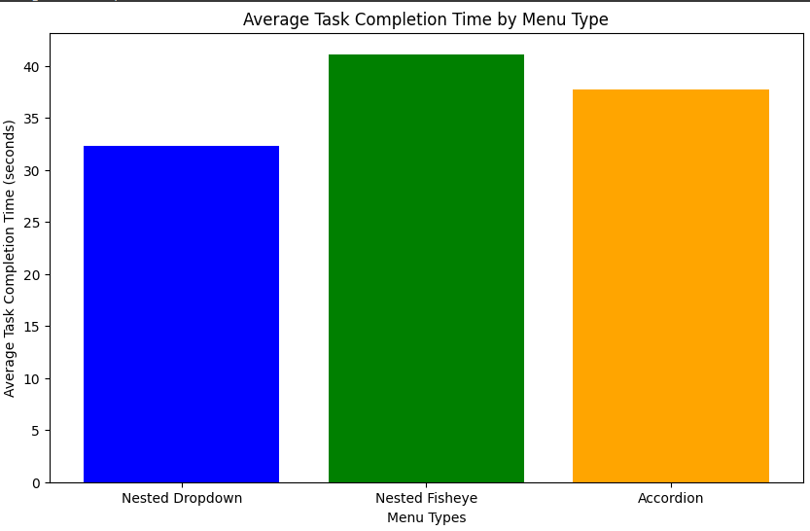

Figure 4

In the study involving 24 participants, the completion times of the tested menu types are shown comparatively in Figure 4. Average completion times for each menu type are listed below, from smallest to largest:

1. Nested Dropdown: 32.34 seconds
2. Accordion: 37.73 seconds
3. Nested Fisheye: 41.13 seconds

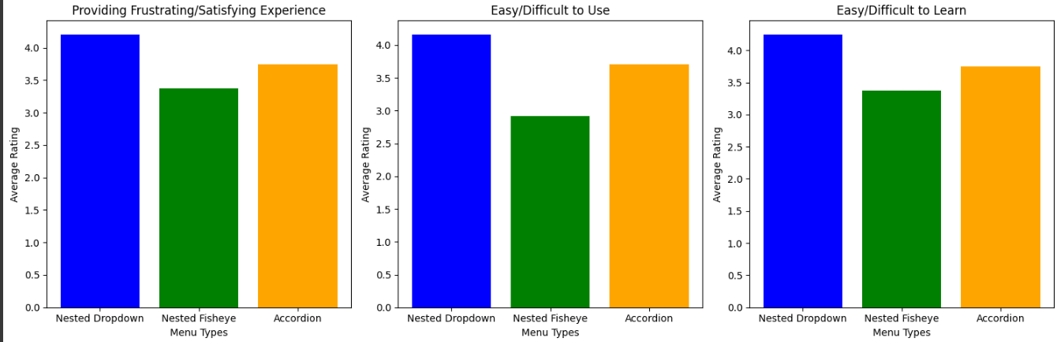

Figure 5

Participants were asked to score the given menu types from 1 to 5 based on the Likert scale system (1 - worst, 5 - best). These ratings were made in 3 categories:

1. Providing Frustrating/ Satisfying Experience (1 - frustrating, 5 - satisfying)
2. Easy/ Difficult to use (1 - easy, 5 - difficult)
3. Easy/ Difficult to learn (1 - easy, 5 - difficult)

The average of the ratings collected from the participants was taken for each menu type. Comparisons of these averages can be seen in Figure 5. Based on the data, it is possible to say the following:

1. Average ratings for "providing frustrating/ satisfying experience" from largest to smallest:
   1. Nested Dropdown: 4.208333333333333
   2. Accordion: 3.75
   3. Nested Fisheye: 3.375
2. Average ratings for " Easy/Difficult to Use" from largest to smallest:
   1. Nested Dropdown: 4.166666666666667
   2. Accordion: 3.7083333333333335
   3. Nested Fisheye: 2.9166666666666665
3. Average ratings for " Easy/Difficult to Learn" from largest to smallest:
   1. Nested Dropdown: 4.25
   2. Accordion: 3.75
   3. Nested Fisheye: 3.375

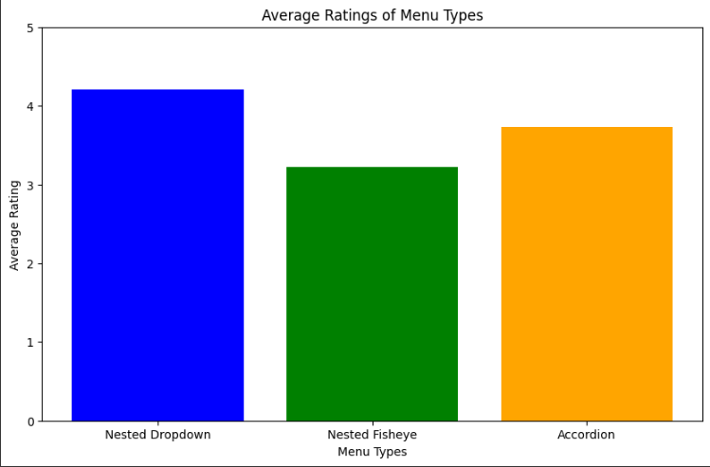

Figure 6

The average of the answers to the Likert Scale questions for each menu type is as follows:

1. Nested Dropdown: 4.208333333333333
2. Accordion: 3.736111111111111
3. Nested Fisheye: 3.222222222222222

A comparative representation of these values ​​is given in Figure 6.

The overall results extracted from the Likert scale questions show the variance and standard deviation for each menu type. For the Dropdown menu, the variance is 0.7808, and the standard deviation is 0.8836, indicating a relatively moderate level of variability in user responses. The Fisheye menu exhibits a higher variance of 1.2011 and a standard deviation of 1.0959, suggesting greater variability and inconsistency in user feedback. In contrast, the Accordion menu demonstrates the lowest variance of 0.6304 and a standard deviation of 0.7940, indicating more consistent user experiences and lower variability in responses. These results provide insight into the user perceptions and experiences associated with each menu type.

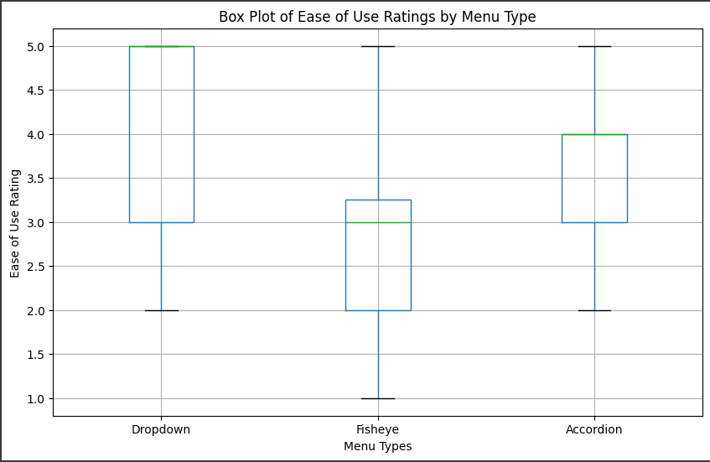

Figure 7

In order to make further evaluation, the ratings for "easy/ difficult to use" and menu types are shown in Figure 7. Also, the correlation between technological capability and ease of use ratings were calculated to find out the connection among them. Calculations are as follows in a largest-to-smallest sequence:

1. Accordion: 0.8000038659036159
2. Nested Fisheye: 0.7895792475371107
3. Nested Dropdown: 0.7491587023046329

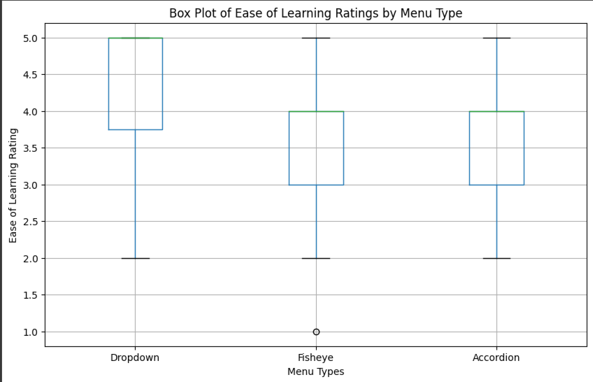

Figure 8

The same process as above was done in "ease of learning ratings by menu type". The results are seen in Figure 8. Moreover, the correlation between technological capability and ease of learning ratings were calculated in the manner. The calculations are listed from highest to lowest:

1. Nested Fisheye: 0.832317
2. Nested Dropdown: 0.724207
3. Accordion: 0.608334

In order to discover between user preferences and performance between the three menu types based on their task completion times and given quantitative feedbacks, descriptive statistics such as mean, median and standard deviation of task completion times and user feedback were calculated for each menu type. Statistical data calculated according to completion time for each menu can be seen below:

1. Nested Dropdown:
   * Average Time (Mean): 32.34 seconds
   * Standard Deviation: 11.57
   * Minimum Completion Time (Min): 15.08 seconds
   * Maximum Completion Time (Max): 58.08 seconds
   * Median: 29.65 seconds
2. Nested Fisheye:
   * Average Time (Mean): 41.13 seconds
   * Standard Deviation: 11.38
   * Minimum Completion Time (Min): 25.36 seconds
   * Maximum Completion Time (Max): 64.31 seconds
   * Median: 40.64 seconds
3. Accordion:
   * Average Time (Mean): 37.73 seconds
   * Standard Deviation: 11.84
   * Minimum Completion Time (Min): 22.22 seconds
   * Maximum Completion Time (Max): 59.18 seconds
   * Median: 36.82 seconds

Statistical data created based on user feedback is as shown below:

1. Nested Dropdown:
   * Average Feedback (Mean): 4.17
   * Standard Deviation: 1.01
   * Minimum Feedback (Min): 2.00
   * Maximum Feedback (Max): 5.00
   * Median: 5.0
2. Nested Fisheye:
   * Average Feedback (Mean): 2.92
   * Standard Deviation: 0.93
   * Minimum Feedback (Min): 1.00
   * Maximum Feedback (Max): 5.00
   * Median: 3.00
3. Accordion:
   * Average Feedback (Mean): 3.71
   * Standard Deviation: 0.86
   * Minimum Feedback (Min): 2.00
   * Maximum Feedback (Max): 5.00
   * Median: 4.00

Quantitative observations and comments given by participants are directly proportional to Likert scale scores. The feedback given supports the numerical and statistical evaluations made.

* Summary

In order to better understand the analysis part, the collected data are summarized under distinguishable headings in this section:

* Task Completion Times

Among the three menu types, the Nested Dropdown menu allowed users to complete tasks in the shortest amount of time. The average completion times for each menu type, from shortest to longest, are:

1. Nested Dropdown: 32.34 seconds
2. Accordion: 37.73 seconds
3. Nested Fisheye: 41.13 seconds

* Overall User Experience

Participants rated their experience using a Likert scale (1 - worst, 5 - best) in three categories: providing a frustrating/satisfying experience, ease/difficulty of use, and ease/difficulty of learning.

Providing a Frustrating/Satisfying Experience:

1. Nested Dropdown: 4.208
2. Accordion: 3.75
3. Nested Fisheye: 3.375

Ease/Difficulty of Use:

1. Nested Dropdown: 4.167
2. Accordion: 3.708
3. Nested Fisheye: 2.917

Ease/Difficulty of Learning:

1. Nested Dropdown: 4.25
2. Accordion: 3.75
3. Nested Fisheye: 3.375

* Variability in User Feedback

The overall results from the Likert scale questions showed the variance and standard deviation for each menu type:

1. Dropdown: Variance: 0.7808, Standard Deviation: 0.8836
2. Fisheye: Variance: 1.2011, Standard Deviation: 1.0959
3. Accordion: Variance: 0.6304, Standard Deviation: 0.7940

These results indicate that the Accordion menu provided more consistent user experiences.

* Ease of Use and Technological Proficiency

The correlation between technological capability and ease of use ratings, calculated for each menu type, showed the following:

1. Accordion: 0.8000
2. Nested Fisheye: 0.7896
3. Nested Dropdown: 0.7492

* Ease of Learning and Technological Proficiency

The correlation between technological capability and ease of learning ratings, calculated for each menu type, showed the following:

1. Nested Fisheye: 0.8323
2. Nested Dropdown: 0.7242
3. Accordion: 0.6083

* User Preferences and Performance

Descriptive statistics for task completion times and user feedback were calculated for each menu type.

Completion Times:

* + Nested Dropdown: Mean: 32.34 seconds, Std Dev: 11.57, Min: 15.08 seconds, Max: 58.08 seconds, Median: 29.65 seconds
  + Nested Fisheye: Mean: 41.13 seconds, Std Dev: 11.38, Min: 25.36 seconds, Max: 64.31 seconds, Median: 40.64 seconds
  + Accordion: Mean: 37.73 seconds, Std Dev: 11.84, Min: 22.22 seconds, Max: 59.18 seconds, Median: 36.82 seconds

User Feedback:

* Nested Dropdown: Mean: 4.17, Std Dev: 1.01, Min: 2.00, Max: 5.00, Median: 5.00
* Nested Fisheye: Mean: 2.92, Std Dev: 0.93, Min: 1.00, Max: 5.00, Median: 3.00
* Accordion: Mean: 3.71, Std Dev: 0.86, Min: 2.00, Max: 5.00, Median: 4.00
* **Discussion and Conclusion**

In this section, the effectiveness and user experience of three different menu types (Nested Fisheye, Nested Dropdown and Accordion) in goal-oriented web tasks were evaluated. Conclusions were reached by evaluating the analysis results of the collected data.

* Interpretation

The completion time of the given tasks by the participants contains important information to understand the effectiveness of menu types in goal-oriented tasks. Finishing times clearly reveal the hierarchy between menu types:

* Nested Dropdown (32.34 seconds): Nested Dropdown menu type provides users with a visible advantage in terms of speed when compared to the other 2 menu types. This suggests that it is the most easy to navigate menu in goal-oriented tasks compared to other 2 menu types. It minimizes the time, required for completing a specific goal.
* Accordion (37.73 seconds): The accordion menu type has an average complete time compared to the other two menu types. Although it is not as fast as nested dropdown, it offers relatively efficient use.
* Nested Fisheye (41.13): Nested fisheye is the menu type with the longest average finishing time compared to other menu types. This data shows that the nested fisheye menu type provides a less effective experience for the user. One of the reasons for this could be that this menu type is originally designed for browse-oriented tasks rather than goal-oriented tasks.

Likert scale evaluations provided by participants also provide insight in the areas of satisfaction, ease of use and learnability for these three menu types. A common result is observed in all three ratings. While the nested dropdown menu is considered the best in all 3 categories by users, the accordion menu is considered average and the nested fisheye is considered less than average compared to the others. Evaluations and analysis of these 3 areas are seen below.

* Providing a Frustrating/Satisfying Experience
  + Nested Dropdown (4,208): This high rating out of 5 shows that users are more satisfied with this menu type when completing the given task.
  + Accordion (3.75): It is possible to say that the Accordion menu provides users with a relatively satisfying experience. However, it is worth mentioning that its rating is closer to nested fisheye, not nested dropdown.
  + Nested Fisheye (3.375): The score given by participants to Nested fisheye shows that users are not satisfied enough with this menu type.
* Ease/Difficulty of Use:
  + Nested Dropdown (4,167): Participants reported that they found the nested dropdown menu easier to use than the other two. It suggests that nested dropdown has a user-friendly design for goal-oriented purposes.
  + Accordion (3,708): This menu type was classified as relatively easy in terms of ease of use. But the rating remained average.
  + Nested Fisheye (2,917): Nested fisheye was again the worst-scored menu type by users. Participants stated that among these 3 menu types, the menu they had the most difficulty in using was nested fisheye.
* Ease/Difficulty of Learning
* Nested Dropdown (4.25): In terms of ease of learning, nested dropdown again received a score well above average. This shows that it is a menu type that should be preferred for ease of learning for users.
* Accordion (3.75): Accordion menu type is classified as relatively easy to learn. It is worth saying that it is above average in terms of scoring and good in terms of learnability.
* Nested Fisheye (3.375): This menu type was marked as the weakest menu type in terms of learnability among the 3 menu types. The rating shows that nested fisheye offers a more challenging experience than the other 2 menus.

The nested dropdown menu type makes a clear difference in all areas compared to the other 2 menu types in terms of providing a satisfactory experience, easy usability and learnability. Considering the completion time of the given tasks, it is an obvious fact that nested dropdown dominates the other two menus in terms of efficiency as well. Although the Accordion menu type does not perform poorly in these 3 areas and in terms of time, it remains average. The nested fisheye menu comes last in all 3 areas. Considering that the completion time is longer than the other two menu types, it is possible to say that nested fisheye is the most unsuitable of these 3 menu types for goal-oriented tasks.

Statistical calculations obtained from Likert scaling questions reveal different thinking tendencies among users. Nested dropdown menu shows moderate variation with a variance of 0.7808 and a median value of 0.8836. Although this data is generally considered normal, it still reveals that users have somewhat different experiences from each other. Nested fisheye menu type is the menu type that shows the highest variability with 1.2011 variance and 1.0959 standard deviation values. This shows that while some users find the menu useful and satisfactory, others think very differently. The Accordion menu gives the most consistent feedback result among the 3 menus, with a variance of 0.6304 and a standard deviation of 0.7940. This indicates that the accordion menu provides a more stable and predictable user experience across different individuals compared to the other two menu types. The consistent variation in the Accordion menu type highlights the reliability of this menu type in terms of addressing a wide range of people.

The feedback given by users who have different levels of familiarity with technology is extremely important in terms of understanding the user's experience level and general satisfaction. It should not be forgotten that when designing user interfaces, it is necessary to take into account that not all users have the same level of knowledge and experience.

Ease of Use and Technological Proficiency

* + Accordion (0.8): The Accordion menu type has the highest correlation in terms of ease of use and technological familiarity compared to the other 2 menu types. This shows that experienced users operate more easily in the accordion menu type.
  + Nested Fisheye (0.7896): Nested fisheye menu also exhibits a very high correlation. This shows that this menu type is better used by people related to technology.
  + Nested Dropdown (0.7492): Although nested dropdown is the menu type with the least correlation value among the 3 menu types, it still shows a high correlation.

Ease of Learning and Technological Proficiency

* + Nested Fisheye (0.8323): Nested fisheye's correlation degree shows that highly experienced users describe this menu type as easier to learn. Users' familiarity with technology and their experience with this menu type are highly correlated with each other.
  + Nested Dropdown (0.7242): Users' technological experience level and their experience with nested dropdown clearly correlate with each other.
  + Accordion (0.6083): The Accordion menu type is the menu that is least dependent on the user's technological experience compared to the other 2 menu types. This accordion is an indication that the menu's design appeals to users with different tech skills and is easy to learn.
* Compare/Contrast with the literature

The findings in the current study, consistent with Bederson's (2003) research, revealed that goal-oriented menu types such as nested dropdown are more effective in goal-oriented tasks . The high performance of the Nested dropdown menu in terms of speed, ease of use, learnability and overall user satisfaction coincides with Bederson's study, which emphasizes the importance of menus designed to be used for hierarchical purposes. At the same time, the perception that the fisheye menu is a browse-oriented menu type rather than a goal-oriented one (Bederson & Shneiderman , 2003) is once again supported by the current study. In addition, the importance of user background has once again emerged with the correlation between users' familiarity with the technology and the feedback they provide. The nested fisheye menu was deemed less effective for goal-oriented tasks due to its dynamic structure.

The findings of the current study partially overlap with the research of Tucker et al (2018). Tucker et al (2018) concluded that accordion menus provide advantages for users with low literacy levels. The results of the current study show that accordion menus are the menu type that appeals to the general audience the most compared to the other two menu types. It can be said that there is a correlation between participants' levels of familiarity with technology and their literacy levels in Tucker's study. Both studies revealed that the accordion menu type appeals to a wide range of users.

The findings of the current study are consistent with the study of Dix, Finlay, Abowd, and Beale (2003), highlighting the importance of reducing cognitive load in user interface design. In the current study, it was also investigated how users' technological literacy levels affected their interactions with menu types. As Dix et al (2003) say, individual differences should be taken into account when designing user interfaces. Additionally, to minimize the short-memory effect, the order of the menus presented to the participants was changed and different tasks were assigned. This is a precaution taken to analyze participants' relationships with menu types more accurately.

* What will be the practical implications of your study? What will UX designers, researchers, and others learn/benefit from your study?

UX designers can benefit from the information provided by the study when choosing the most appropriate menu type for goal-oriented tasks during website design. So much so that, among the 3 menu types tested in the study, the nested dropdown menu stands out as the best option for such tasks in terms of short completion times, high user satisfaction, ease of use and ease of learning. Compared to the other two menu types, the Accordion menu appeals to a wider user base in terms of correlation values. In this case, it may be useful when designing websites with different user profiles. It was concluded that the nested fisheye menu type was not very effective for goal-oriented tasks. These findings are data that both designers and researchers should consider in their studies.

* Critique your study (limitations) and recommended improvements

Most of the individuals included in the current study were individuals who stated that they were familiar with technology. There was a difference of over 60% in the ratio of male and female participants. In addition, the participants with the lowest education level were high school graduates. Considering these situations, it would not be wrong to say that the data collected does not reflect the general society. In order to better express the general user base, the number of individuals participating in the study could have been increased and healthier results could have been obtained with people from different backgrounds.

* Suggestions for further research

Future research on this subject may include studies on individuals of different age groups and technological abilities. A study that aims to appeal to a wider range of subjects can be conducted by increasing the number of participants participating in the test. By including the number and rates of errors made in menu types in such a study, the perspective that the study provides to the readers can be expanded. Additionally, end-user testing was conducted in the current research. Interesting results regarding menu types can be obtained through live data by performing A/B tests of websites. This will likely involve more people and provide more accurate data than the current study.

# References

Bederson, B. B., & Shneiderman , B. (2003). Fisheye Menus. In B. B. Bederson, & B. Shneiderman, *The Craft of Information Visualization. Readings and Reflections* (pp. 299-307).

Dix, A., Finlay, J., Abowd, G. D., & Beale, R. (2003). In A. Dix, J. Finlay, G. D. Abowd, & R. Beale, *Human-Computer Interaction* (pp. 12-58).

Tucker, S., Summers, K., McGowan, T., & Klimas, C. (2018). *Evaluating the Benefit of Accordion Web Elements for Low Literacy Populations.* Springer International Publishing.